Enoch’s Stomp Vineyard and Winery

871 Ferguson Road (FM 4312)

Harleton, TX 75651

(903) 240-1587

Rental Agreement

Enoch’s Stomp Property Description:
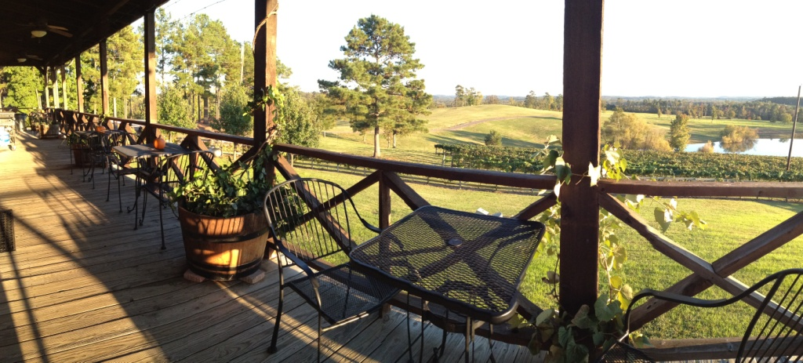
Nowhere in Texas will you find a setting more beautiful than Enoch’s Stomp Vineyard and Winery. It is a perfect place for your special event, whether it be a wedding, family reunion, corporate event or group outing. The property is situated among the rolling hills of Harleton in East Texas. Eleven acres of grapevines surround the winery. Rental allows access to all 89 property acres. Events may be held indoors or out.

Two separate buildings are on the property, our restaurant and the winery. Enoch's restaurant is open for dinner Friday and Saturday from 5pm until 10pm. The winery opens at noon Wednesday through Sunday and closes at 6pm with the exception of a 10pm close on Friday and Saturday. Dining from our “pub menu” is available in the winery tasting room Thursday through Sunday.
Attached to the winery are the Event Center and tasting room, both of which are available for rental. The 5000 sq. ft., climate controlled indoor Event Center has a seating capacity of 250. For larger groups the tasting room (1300 sq. ft.) can serve as overflow for an additional 100 guests.
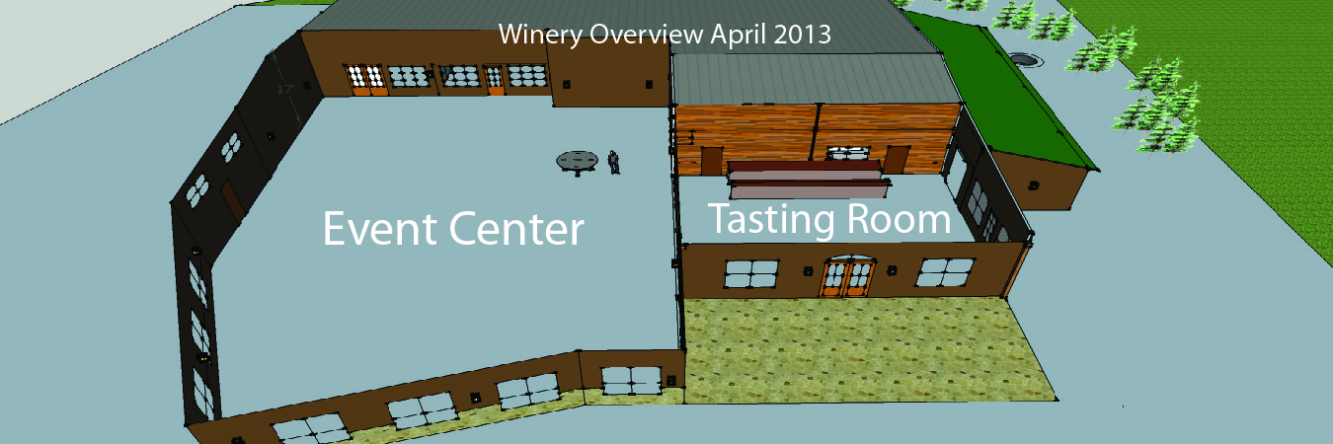

Rental Pricing
Prices vary depending on date, size of party, and additional needs. Please call Elsie at (903) 387-0887 or leave a message on our cell phone (903) 240-1587. Weddings and large groups will need to rent the Event Center. Small groups may find the restaurant to be more appropriate.

Event Center Only

Rental includes use of our inventory of tables (25 round, 20 rectangular) and folding wedding chairs (250 white and 240 black). A staffed wine bar will be available for your guests during your event. All alcohol must be served by Enoch's Stomp staff. A short rehearsal is permitted however you must work around any other scheduled events. Please discuss any additional decorations with our Event Coordinator. A dressing room is provided for the bridal party. Approved caterers are welcome to use our limited-service kitchen adjacent to the Event Center. The barrel room can be made available if needed for your event planning. During your event, Enoch's tasting room and restaurant will be open for business as usual unless other arrangements are made.

Event Center with Wine Tasting Room
Adjacent to the Event Center is Enoch's wine tasting room. Larger parties requiring overflow from the Event Center will find it necessary to rent this room. Clients desiring more privacy without the interruption of normal tasting room traffic should consider this additional rental as well. Rental of the tasting room in and of itself is not available.

Entire Property Rental
Clients desiring complete privacy may opt to rent the entire property for $18,000. This includes the winery, event center, tasting room, restaurant and all 89 acres. Though the property is yours all day, Enoch's tasting room will remain open to the public for retail sales until the start of your event.

Restaurant Rentals
During restaurant serving hours, small groups may desire to reserve the second floor of Enoch's restaurant. The private room seats 30 and the adjacent loft seats 20.
The restaurant is also available for rental during non-service hours.
Please call for pricing.

Catering
Enoch's Stomp offers catering. If interested we will put you in contact with our executive chef. Catering fees are in addition to facility rental fees.

Outside Catering
Enoch’s Stomp can provide a list of outside caterers upon request. All caterers must be approved by the Harrison County Department of Health prior to event. It is the renters responsibility to assure such approval is obtained. Caterers are welcome to use our limited service kitchen adjacent to the Event Center. The restaurant kitchen is not available unless the entire property is rented.

Applicable to All Rentals
Wine will be sold separately. Prices range from $10 to $25 per bottle and $4 to $7 per glass. A wine list will be provided at your request. A 10% discount will be given for wine purchased in advance of your event.
The winery will be open for business as usual Wednesday through Sunday. Your guests are welcome to visit the winery and tasting room during our normal operating hours.
Enoch’s staff will assist you in serving wine during your event.
A booking deposit of 50% is required to reserve your event date. The remaining balance is due two weeks prior to event.

A refundable damage deposit of $500 is required for any rental. This deposit is due with the remaining balance two weeks before the event.
Cancellation greater than one month prior to event will result in return of 50% of booking deposit. Cancellation less than one month prior to event will result in complete forfeiture of deposit.

Appropriate sales tax will be added.

At Enoch’s Stomp we encourage our renting clients to take on a sense of ownership of the winery. Treat the place with respect, honor the beauty of the environment and leave the grounds better than you found them. Basic clean up is expected unless other arrangements are made with the management. Failure to do so will result in loss of damage deposit. Return of damage deposit, in full or part, is solely at the discretion of Enoch's Stomp management. Client will be held responsible for any incurred costs over and above the deposit resulting from damage to the property.
Under TABC regulations alcohol other than Enoch’s Stomp wine is not allowed on the premises. Violators are breaking the law and put the winery’s license at risk. Such persons will be escorted off the property. Willful disregard of this policy by any person associated with renting clients event will result in complete loss of client’s damage deposit. We remind you the legal drinking age is 21. Appropriate legal identification is required. Enoch’s Stomp is a non-smoking facility. These policies are strictly enforced. Enoch’s Stomp is NOT permitted to serve beer, however concessions can be made as long as the renter agrees to certain stipulations outlined in discussion with Enoch’s Event Manager.
Use of Enoch’s Stomp property is at the client’s risk. In signing this contract the client agrees to terms set forth herein and will not hold Enoch’s Stomp owners, employees and affiliates liable for damages or injuries of any kind.
Enoch’s Stomp is excited about holding your event on our premises. We are willing to work with you to make your special day one you will cherish forever. Outside catering, DJ’s, bands, music, and the like must be approved by Enoch’s Stomp staff. We look forward to seeing you at the vineyard.
Sincerely,
Enoch

Contact Information.
Telephone: (903) 240-1587
Email: info@enochsstomp.com
Website: www.enochsstomp.com
Fax: (903) 663-8725
Winery address: 871 Ferguson Rd., Harleton, TX, 75651
Mailing address: 106 Hunters Creek Dr., Longview, TX, 75605

By signing below you are confirming you have read this document in its entirety and are entering into a binding contract outlined by the terms of this document with Enoch’s Stomp Vineyard and Winery, L.L.C.

Printed name: ________________________________________
Signature: ________________________________________
Date: ________________________________________

